API Naming Convention 2

Vendor Agnostic API Naming Convention 2

Middleware Artifacts Naming Convention 2

MuleSoft-specific API Naming Convention 3

Middleware Artifacts Naming Convention 3

# API Naming Convention

## Vendor Agnostic API Naming Convention

### Middleware Artifacts Naming Convention

Middleware artifacts are named based on the type of an artifact and its purpose. Different middleware platforms have various types of artifacts but most of them can be grouped into the following categories:

* Connectors
* Flows
* Tasks
* Custom objects and methods
* Configurations

Connectors are platform-provided or custom integrations to third-party platforms. For example, a common connector is a database connector for a specific database platform such as Oracle or SQL Server. Another example is a Salesforce connector. Connector naming convention varies with each middleware platform, and each platform has its best practice standards. As a best practice, name the connector after the platform it is connecting to. For example, “MySalesforceConnector”.

Flows and sub-flows are groupings of connectors and tasks in a logical workflow. A flow name should indicate the purpose and type of a flow. If this is an API-based flow, it is recommended to have the word “api” in the flow name. The word “flow” should be at the end of the flow name. Typically, flow names are all lower-cased, with words concatenated with a dash character. For example, “customer-api-flow” or “address-sub-flow”. Batch mode flows and routines should have the word “batch” in the name to indicate that this flow or sub-flow is not triggered via a REST or SOAP API, but rather is a scheduled batch process. For example, “account-sync-batch-flow”.

Tasks and routines should contain the key operation in the name. For example, if the task is to call a web service, the name should contain callWebService or similar. Task or operation names are usually lower-cased, following Hungarian notation, similar to how we define Java methods.

Custom objects and methods should follow objects and methods naming convention as described in the previous section of this document.

Finally, configuration files follow the naming convention based on the main programming language used within a particular middleware platform. As most of the middleware platforms are built on Java programming language except for Microsoft BizTalk, the configuration files and folders should be named following Java file naming conventions.

## MuleSoft-specific API Naming Convention

### Middleware Artifacts Naming Convention

Mulesoft middleware artifacts are separated into the following:

* Flows
* Sub-flows
* Connectors
* Mule configuration files

Mule flow and sub-flow names should be all lower-cased, with words separated by dashes. API-based flows should contain the word “api”. All flow names should end with the word “flow”. All sub-flow names should end with a word “sub-flow”. Batch flows should contain the word “batch” in the name of the flow or sub-flow. For example, “customer-apiFlow” or “account-sync-batchFlow”.

In addition, the flows and sub-flows that are tied to a specific platform such as Anypoint MQ, should have “mq” next to the word “flow”. For example, “account-sync-mqFlow”.

The Mule connectors, as they are named in the flows, should indicate the source system that they are used to connect to. For example, a Mulesoft Salesforce Connector should have the target Salesforce instance in the name of the connector.

It is common to also label specific connectors such as Logging or Anypoint MQ with an all-CAPS prefix:

* “LOG:” for a default logging connector
* “JSON:” for a JSON logging connector
* “MQ:” for an Anypoint MQ connector
* “SFDC:” for a Salesforce connector
* “DB:” for a database connector

For example, “LOG: Log Message Payload” to log the message payload.

A screenshot below shows how the connector names are defined in a sample Mule flow.

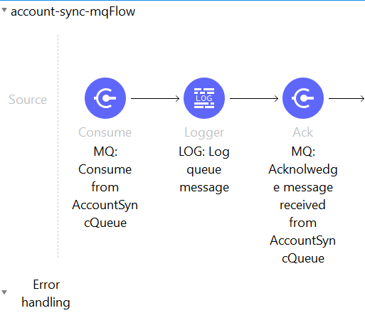

Mulesoft configuration files follow the following naming convention:

* All files are lower-cased
* Words are concatenated with dashes in the file names

For example, “mule-app.propertes” or “pom.xml”.